2025 Annual Membership Fees

Membership fees cover a year from the month you sign up. This covers national and local registration.

Youth Member Fees: $125

Adult Membership Fees: $95

Registration can be paid by cash, check, or card to Pacific Harbors Council call 253-682-2217 or email [PHC@scouting.org](mailto:PHC@scouting.org). If registering online, the fee will be collected as the last step by credit card.

Financial Assistance is available, talk to your unit leader or contact Pacific Harbors Council at 253-682-2217 or [PHC@scouting.org](mailto:PHC@scouting.org). Do not let finances prevent joining, we are here to help!

\*If requesting financial assistance, please do not register online\*

Individual units may have additional dues that are separate from registration.

Scout Life Magazine is an optional youth focused magazine arriving once a month covering Scouting topics, exciting stories from across the country, and educational topics. If you would like to receive Scout Life Magazine, please indicate that when you sign up.

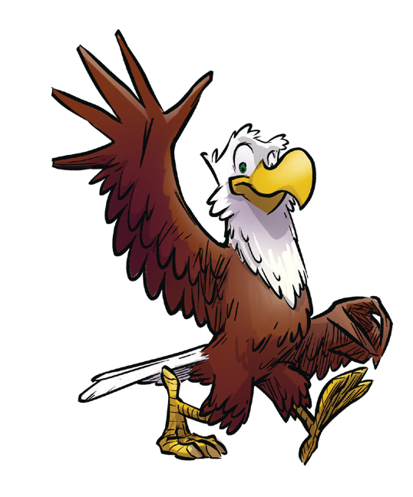

$15

/YR

2025 Annual Membership Fees

Membership fees cover a year from the month you sign up. This covers national and local registration.

Youth Member Fees: $125

Adult Membership Fees: $95

Registration can be paid by cash, check, or card to Pacific Harbors Council call 253-682-2217 or email [PHC@scouting.org](mailto:PHC@scouting.org). If registering online, the fee will be collected as the last step by credit card.

Financial Assistance is available, talk to your unit leader or contact Pacific Harbors Council at 253-682-2217 or [PHC@scouting.org](mailto:PHC@scouting.org). Do not let finances prevent joining, we are here to help!

\*If requesting financial assistance, please do not register online\*

Individual units may have additional dues that are separate from registration.

Scout Life Magazine is an optional youth focused magazine arriving once a month covering Scouting topics, exciting stories from across the country, and educational topics. If you would like to receive Scout Life Magazine, please indicate that when you sign up.



$15

/YR